

Defect Management Processes
And
Bugzilla Guidelines
Version History:

Ver. No. | Date | Comments | Prepared By | Reviewed By | Approved By
1.0 | 14th Dec, 2009 | Initial Draft | Neha Gupta | Abhishek Rautela | Mr. Sudhir Saxena
1.1 | 1st May, 2010 | Reviewed and release | Neha Gupta | Abhishek Rautela | Mr. Sudhir Saxena
2.0 | 13th May, 2013 | Update section 6,7,8&9 update section 8 | Deepak Gupta | Rahul Raj | Ajay Kumar Zalpuri
2.1 | 27th Jan 2016 | Introduce guideline for ANNOVA for defect analysis in section9.5 | Rahul Raj | Dhananjay Kr. | Ajay Kumar Zalpuri

Table of Content

1. Author 4
2. License, Copyrights and Disclaimer 4
3. Revision History 4
4. Introduction 4
5. Purpose of Guidelines and Best Practices 4
6. Defect Life Cycle 4
7. Priority and Severity 6
8. How to Write a Useful Bug Report 9
9. Using Bugzilla 10
9.1 Set up a Bugzilla Account 10
9.2 Reporting a New Bug 10
9.3 Searching for Information in Bugzilla 14
9.4 Watching for Users or Specific Bugs in Bugzilla 15

- Author
These guidelines have been summarized for Project team members keeping in mind the current trends and best bug reporting practices for Bugzilla. These guidelines will help and ensure efficient bug reporting and optimizing the utilization of Bugzilla tool.

- License, Copyrights and Disclaimer
You are permitted to use and distribute this document for any non commercial purpose as long as you retain this license & copyrights information.

This document is provided on “As-Is” basis. The author of this document will not be responsible for any kind of loss for you due to any inaccurate information provided in this document.

- Revision History
If you are editing this document, you are required to fill the revision history with your name and time stamp so that anybody can easily distinguish your updates from the original author.

- Introduction
Defects may be raised during development, review, testing or use of a software product. They may be raised for issues in code or the working system, or in any type of documentation including development documents, test documents or user information such as “Help “or installation guides.

- Purpose of Guidelines and Best Practices
Defect Management process plays key role during Software Testing life cycle, since one of the objectives of testing is to find defects, the discrepancies between actual and expected outcomes need to be logged as defects or bugs or incidents. In order to manage all defects to completion, an organization should establish a process and rules for classification.

There are several standards that exist in the industry. None of them are wrong or bad and you may follow any of them. What is more important is, selecting one standard approach and ensuring that everyone is following it.

- Defect Life Cycle
A Defect/Bug Life Cycle is made up of series of phases.

No
Yes
Later
No
Bug is identified
Report the Bug
Is the bug valid?
Is the bug important to be fixed now?
Bug is assigned
Test Bug in new Build
Bug is fixed
Is the bug fixed?
Close
Reason can be
Invalid
Duplicate
Technical Understanding
Bug is deferred
Yes
Yes
No

Yes

No

- New:
when the bug is identified and logged in bug tracking tool for the first time, its state will be "NEW".

- Open / closed:
After a tester has posted a bug; the Test lead validates the bug. If bug is valid then he changes the state as "OPEN" and if the bug is invalid then the lead changes its state to "CLOSED".

- Assign:
After Test lead changes the state as "OPEN", he assigns the bug to corresponding developer or developer team lead and the bug status is changed to "ASSIGN".

- Rejected:
If the developer feels that the bug is not valid or it has some technical limitations and cannot be fixed, he rejects the bug. He changes the state of bug to "REJECTED".

- Duplicate:
If the bug is logged is repeated twice or the two bugs reported has alike results and steps to reproduce, then one bug status is changed to "DUPLICATE".

- Deferred:
If the development team lead decides to fix the bug in next release due to lack of time or the priority of the bug is low then he changes the state to "DEFERRED", which is later changes to "ASSIGN" when the bug is taken in consideration to be fixed.

- Verified:
once the bug is fixed and the status is changed to "Fixed", the tester tests the bug. If the bug is not reproducible in the software, he changes the status to "VERIFIED".

- Reopened:
once the bug is fixed and the status is changed to "Fixed", the tester tests the bug. If the bug is reproducible in the software, he changes the status to "REOPENED".

- Closed:
after the bug status is changes to "REJECTED" or "DUPLICATE" or "VERIFIED" the Test Lead verifies the comments added by the development or Testing team. When he is satisfied with the comments he changes the state to "CLOSED".

- Priority and Severity
Priority means how fast it has to be fixed. Normally talking about this, “High Severity” bug are marked as “High Priority” bugs & it’s should be resolved as early as possible, but this case is not all the time. There can be different exceptions to this rule and depending on the nature of the application it can be change from company to company. Let’s take a example to the Priority: e.g. To deal with all issues present what issues to be consider on first based on its urgency or importance on application under test. Adding this field in while reporting bug will help analyzing the Bug Report.

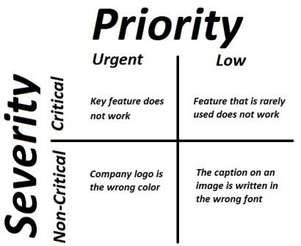

Priority:
- Priority means how fast it has to be fixed.
- Priority is related to scheduling to resolve the problem.
- The priority status is set based on the customer requirements.
- Based on ‘Project Priorities the product fixes are done.
- The Priority status is set by the tester to the developer mentioning the time frame to fix a defect. If High priority is mentioned then the developer has to fix it at the earliest.

Severity:
- It is totally related to the quality standard or devotion to standard.
- Severity means how severe it is affecting the functionality.

- The severity type is defined by the tester based on the functionality.
- The Test Engineer can decide the severity level of the bug.
- Based on Bug Severity the product fixes are done.
- Also we can say The Severity status is used to explain how badly the deviation is affecting the build.
Classification in Severity and Priority (for Bugzilla)
- Blocker
Application crashes or fails to initialize. Database connectivity issue where system is unable to fetch data or fetches wrong data. The defect prevents QA from testing the feature area, sub-area or functionality of the feature.
- Critical
Important feature in test fails. This is a bug that users would experience such as: data corruption, calculation errors, incorrect data, and system crash on common user scenarios, significant QA risk, and major UI defects.
- Major
Secondary feature in test is not operating as expected, this is bug that users would experience like UI crashes for a screen, Loss of function, calculation errors but some work around possible.
- Normal
Secondary feature in test has some not so important issues. Minor feature in test is not operating as expected, A bug because of some wrong contents and some minor UI changes, regular issue or some loss of functionality under specific circumstances.
- Minor
Secondary feature in test has some UI issues. Minor feature in test has some not so important issues or other problem where easy workaround is present.
- Trivial
Minor feature in test has some UI issues or typos.
- Enhancement
any modification in the existing product which is not covered in requirements, but the stated modification shall be essential for look and feel or for business.
Note: We can ignore Minor and Trivial as both are not useful for short delivery projects.

Priority defines the order in which we should resolve a defect.
They are classified in following sections
- Priority 1
- Should be fixed as soon as possible.
- The application hangs or crashes (Blockers, Critical and Show stopper Issues).
- Data loss taking place.
- Memory Leakages are identified.
- Implementation is opposite to the requirement specified.
- Priority 2
- Should be considered to fix as soon as possible.
- Having important feature some logical issues. (Wrong functionality implemented).
- Performance Issues.
- Major Cosmetic Issues
- Important Typo errors to be fixed
- Priority 3
- Should be considered to fix.
- Having secondary or other feature some logical issues. (Wrong functionality implemented).
- Minor Cosmetic Issues
- Priority 4
- Should be considering to be fixed before build is released to clients.
- Minor Cosmetic Issues.
- Other Typo Errors.
- Priority 5
- Enhancement and Suggestion.
Note: Some bug reporting tool as High, Medium and Low as their Priority values in their drop-down for Priority values.
- How to Write a Useful Bug Report
Useful bug reports are ones that get bugs fixed. A useful bug report normally has two qualities:
- Reproducible. If an engineer can't see it or conclusively prove that it exists, the engineer will probably stamp it "WORKSFORME" or "INVALID", and move on to the next bug. Every detail you can provide helps.
- Specific. The quicker the engineer can isolate the issue to a specific problem, the more likely it'll be expediently fixed. (If a programmer or tester has to decipher a bug, they spend more time cursing the submitter than fixing or testing the problem.)
Let's say the application you're testing is a web browser. You crash at foo.com, and want to write up a bug report:

Not Good:
"My browser crashed. I think I was on foo.com. My computer uses Windows. I think that this is a realy bad problem and you should fix it now. By the way, your icons really suck. Nobody will use your software if you keep those ugly icons. Oh, and my grandmother's home page doesn't look right, either, it's all messed up. Good luck."
Good:
"I crashed each time when I went to foo.com, using the 10.28.99 build on a Win NT 4.0 (Service Pack 5) system. I also rebooted into Linux, and reproduced this problem using the 10.28.99 Linux build.
It again crashed each time upon drawing the Foo banner at the top of the page. I broke apart the page, and discovered that the following image link will crash the application reproducibly, unless you remove the "border=0" attribute:
<IMG SRC="http://foo.com/images/topics/topicfoos.gif" width=34 height=44 border=0 alt="News">"

Some key points to make Bug report more effective:
- Defect Title and summary
- Defect Description with steps to reproduce
- Expected and actual results.
- Date the incident was discovered.
- Identification or configuration item of the software or system.
- Software or system life cycle process in which the incident was observed.
- Description of the anomaly to enable resolution.
- Degree of impact on stakeholder(s) interests.
- Severity of the impact on the system.
- Urgency/priority to fix.
- Status of the incident like open, deferred, duplicate, waiting to be fixed, fixed awaiting confirmation test or closed.
- Conclusions and recommendations.
- Global issues, such as other areas that may be affected by a change resulting from the defect.
- Change history, such as the sequence of actions taken by project team members with respect to the incident to isolate, repair and confirm it as fixed.

- Using Bugzilla

9.1 Set up a Bugzilla Account
If you want to use Bugzilla, first you need to create an account. Consult with the administrator responsible for your installation of Bugzilla for the URL you should use to access it. If you're test-driving Bugzilla, use the URL:

- Click the "Open a new Bugzilla account" link, enter your email address and, optionally, your name in the spaces provided, then click "Create Account".
- Within moments, you should receive an email to the address you provided above, which contains your login name (generally the same as the email address), and a password you can use to access your account. This password is randomly generated, and can be changed to something more memorable.
- Click the "Log In" link in the yellow area at the bottom of the page in your browser, enter your email address and password into the spaces provided, and click "Login".

You are now logged in. Bugzilla uses cookies for authentication so, unless your IP address changes, you should not have to log in again.

9.2 Reporting a New Bug
Before you enter your bug, use the Bugzilla Query Page to determine whether the defect you've discovered is a known bug, and has already been reported. (If your bug is the 37th duplicate of a known issue, you're more likely to annoy the engineer. Annoyed engineers fix fewer bugs.)
Next, be sure that you've reproduced your bug using a recent build. (Engineers tend to be most interested in problems afflicting the code base that they're actively working on, rather than those in a code base that's hundreds of bug fixes obsolete.)
If you've discovered a new bug using a current build, report it in Bugzilla:

  - From your Bugzilla main page, choose "Enter a new bug".
  - Select the product that you've found a bug in.
  - Enter your E-mail address, Password, and press the "Login" button. (If you don't yet have a password, leave the password text box empty, and press the "E-mail me a password" button instead. You'll receive an E-mail message with your password shortly.)

Now, fill out the form. Here's what it all means:

Where did you find the bug?
  - Product: In which product did you find the bug?
You just filled this out on the last page.
  - Version: In which product version did you find the bug?
If applicable.
  - Component: In which component does the bug exist?
Bugzilla requires that you select a component to enter a bug. (If they all look meaningless, click on the Component link, which links to descriptions of each component, to help you make the best choice.)
  - Platform: On which hardware platform did you find this bug? (e.g. Macintosh, SGI, Sun, PC.)
If you know the bug happens on all hardware platforms, choose 'All'. Otherwise, select the platform that you found the bug on or “Other if your platform isn't listed.
  - OS: On which Operating System (OS) did you find this bug? (e.g. Linux, Windows NT, Mac OS 8.5.)
If you know the bug happens on all OSs, choose 'All'. Otherwise, select the OS that you found the bug on, or "Other" if your OS isn't listed.
  - Summary: How would you describe the bug, in approximately 60 or fewer characters?
A good summary should quickly and uniquely identify a bug report. It should explain the problem, not your suggested solution.

    - Good: "Cancelling a File Copy dialog crashes File Manager"
    - Bad: "Software crashes"
    - Bad: "Browser should work with my web site"

  - URL: On what URL did you discover this bug?
If you encountered the bug on a particular URL, please provide it (or, them) here. If you've isolated the bug to a specific HTML snippet, please also provide a URL for that, too.
  - Description: The details of your problem report, including:
- Overview: More detailed restatement of summary.
- Drag-selecting any page crashes Mac builds in the NSGetFactory function.
- Steps to Reproduce: Minimized, easy-to-follow steps that will trigger the bug. Include any special setup steps.
- View any web page. (I used the default sample page, resource:/res/samples/test0.html)
- Drag-select the page. (Specifically, while holding down the mouse button, drag the mouse pointer downwards from any point in the browser's content region to the bottom of the Browser’s content region.)
  - Actual Results: What the application did after performing the above steps.
The application crashed.
  - Expected Results: What the application should have done, were the bug not present.
The window should scroll downwards. Scrolled content should be selected.
(Or, at least, the application should not crash.)
  - Build Date & Platform: Date and platform of the build in which you first encountered the bug. Build 2006-08-10 on Mac OS 10.4.3
  - Additional Builds and Platforms: Whether or not the bug takes place on other platforms (or browsers, if applicable).
Doesn't Occur On Build 2006-08-10 on Windows XP Home (Service Pack 2)
  - Additional Information: Any other useful information.
For crashing bugs:
- Windows: Note the type of the crash, and the module that the application crashed in (e.g. access violation in apprunner.exe).
- Mac OS X: Attach the "Crash Reporter" log that appears upon crash. Only include the section directly below the crashing thread, usually titled "Thread 0 Crashed". Please do not paste the entire log!
Double-check your report for errors and omissions, then press "Commit". Your bug report will now be in the Bugzilla database
The status and resolution fields define and track the life cycle of a bug.
  - Importance
The importance of a bug is described as the combination of its priority and severity, as described below.
  - Priority
This field describes the importance and order in which a bug should be fixed. This field is utilized by the programmers/engineers to prioritize their work to be done. The available priorities range from P1 (most important) to P5 (least important).
  - Severity
This field describes the impact of a bug.
  - Platform
This is the hardware platform against which the bug was reported. Legal platforms include:
- All (happens on all platforms; cross-platform bug)
- Macintosh
- PC
Note: When searching selecting the option "All" does not select bugs assigned against any platform. It merely selects bugs that are marked as occurring on all platforms i.e. are designated "All".
  - Operating System
This is the operating system against which the bug was reported. Legal operating systems include:
- All (happens on all operating systems; cross-platform bug)
- Windows
- Mac OS
- Linux
Sometimes the operating system implies the platform, but not always. For example, Linux can run on PC and Macintosh and others.
  - Assigned To
This is the person in charge of resolving the bug. Every time this field changes, the status changes to NEW to make it easy to see which new bugs have appeared on a person's list.
The default status for queries is set to NEW, ASSIGNED and REOPENED. When searching for bugs that have been resolved or verified, remember to set the status field appropriately.
  - Various Status & Resolutions in Bugzilla
STATUS | RESOLUTION
The status field indicates the general health of a bug. Only certain status transitions are allowed. | The resolution field indicates what happened to this bug.
UNCONFIRMED  This bug has recently been added to the database. Nobody has validated that this bug is true. Users who have the "unconfirmed" permission set may confirm this bug, changing its state to NEW. Or, it may be directly resolved and marked RESOLVED.  NEW  This bug has recently been added to the assignee's list of bugs and must be processed. Bugs in this state may be accepted, and become ASSIGNED, passed on to someone else, and remain NEW, or resolved and marked RESOLVED.  ASSIGNED  This bug is not yet resolved, but is assigned to the proper person. From here bugs can be given to another person and become NEW or resolved and become RESOLVED.  REOPENED  This bug was once resolved, but the resolution was deemed incorrect. For example, a WORKSFORME bug is REOPENED when more information shows up and the bug is now reproducible. From here bugs are either marked ASSIGNED or RESOLVED. | No resolution yet. All bugs which are in one of these "open" states have the resolution set to blank. All other bugs will be marked with one of the following resolutions.
RESOLVED  A resolution has been taken, and it is awaiting verification by QA. From here bugs are either re-opened and become REOPENED, are marked VERIFIED, or are closed for good and marked CLOSED.  VERIFIED  QA has looked at the bug and the resolution and agrees that the appropriate resolution has been taken. Bugs remain in this state until the product they were reported against actually ships, at which point they become CLOSED.  CLOSED  The bug is considered dead, the resolution is correct. Any zombie bugs who choose to walk the earth again must do so by becoming REOPENED. | FIXED  A fix for this bug is checked into the tree and tested.  INVALID  The problem described is not a bug.  WONTFIX  The problem described is a bug which will never be fixed.  DUPLICATE  The problem is a duplicate of an existing bug. Marking a bug duplicate requires the bug# of the duplicating bug and will at least put that bug number in the description field.  WORKSFORME  All attempts at reproducing this bug were futile, and reading the code produces no clues as to why the described behavior would occur. If more information appears later, the bug can be reopened.  MOVED  The problem was specific to a related product whose bugs are tracked in another bug database. The bug has been moved to that database.

Searching for Information in Bugzilla
You can setup your searches in Bugzilla so you find information useful to you.

  - To search bugs related to the practices library
    - A Comment (contains all of the words/strings): [PracLib]
  - Search for bugs related to a given person or specific dates when bugs where changed
  - You can alternatively setup your own search in Bugzilla:
Please fill up the form displayed under in the screenshot:
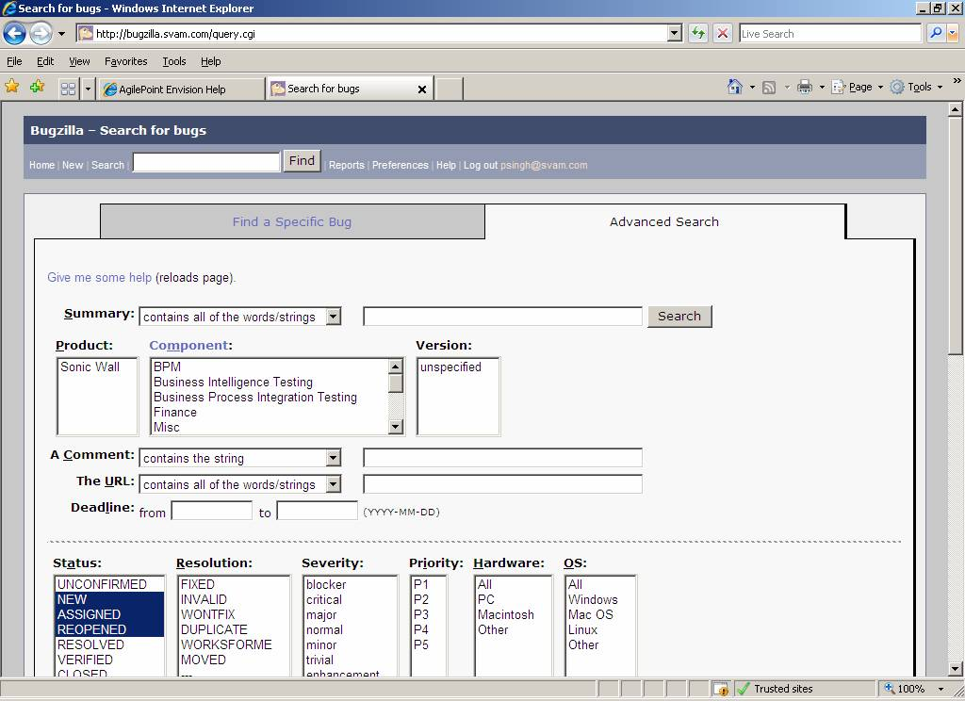

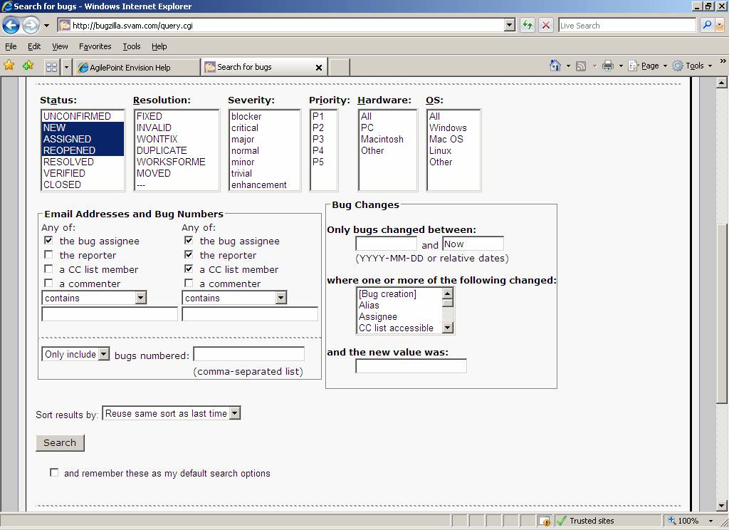

Watching for Users or Specific Bugs in Bugzilla
- You can define users to watch in Bugzilla
  - Go to Preferences page, Email Preferences tab

  - You can define what users you will be watching
    - One is the default inbox user for content related bugs
      - Every time a new bug is created and assigned to the Content component, an email will be sent to you
    - You can also specific real users you would like to watch, so you are notified of their actions in Bugzilla
- You can define individual bugs to watch
  - Besides all bugs assigned to the default inbox user mentioned above, you can receive notifications about individual bugs. Note: when a bug is assigned to someone other than the default inbox user, you will no longer receive notifications.
  - In order to watch specific bugs, add your email address in the cc field of a bug in the corresponding Bugzilla page
    - You can add CC in the People section of this page, or down to the middle of this page you find a check box titled “Add your_name <your_email> to CC list”
With that you receive an email every time there is a comment to that bug, or it change state (level of notifications is defined in the Email Preferences page).

9.5 Annova for defects

Root cause analysis will be done for the system testing defects by the team members of the project. Members can be either developer/Testers/PM. After root cause ANNOVA will be done on the basis of defect category phase wise. ANNOVA should be done by using Minitab statically tool and the result will be passed when P value should be greater than .05 ( Its shows that defects data are equally distributed.)

